**“SMART HELMET”**

**PROJECT REPORT**

**(2023-2024)**



**SUBMITTED BY**

**NAME OF THE STUDENTS REGISTER NUMBER**

1.T.KATHIRAVAN 22403350

2.S.MAYILSAMY 22403355

3.S.PRIYADHARSHNI 22405941

4.M.RISHIKESH 22403361

5.G.SHANKAR 22403364

6.P.MANOJ 22491600

**GUIDED BY**

**Mr. C. MEGANATHAN [ME.,/HOD].,**

**Submitted for partial fulfillment of the requirements for the award of**

**DIPLOMA IN ELECTRONICS AND COMMUNICATION ENGINEERING**

**Of the state board of technical education government of Tamilnadu.**

**KONGHU VELALAR POLYTECHNIC COLLEGE,**

**[Approved by AICTE New Delhi, Affiliated by DOTE]**

**SEENAPURAM, ERODE-638057.**

**CERTIFICATE**

**KONGHU VELALAR POLYTECHNIC COLLEGE**

**Approved by AICTE New Delhi, AFFILIATED BY DOTE**

**SEENAPURAM, ERODE-638057**

**DEPARTMENT OF ELECTRONICS AND COMMUNICATION ENGINEERING**

**PROJECT APPROVAL SHEET**

**This is to certify that the project report titled**

“**SMART HELMET”**

**Is the approved work done by**

**NAME : ......................................................**

**REGISTER NO : .......................................................**

Submitted in partial fulfillment for the award of diploma in Electronics and Communication Engineering during the year 2023-2024

**Project Guide Head of the Department**

Submitted for the board examination held on ………..........

**Internal Examiner External Examiner**

**ACKNOWLEDGEMENT**

We are most indebted to our parents, with whose support we able to

make our dreams of becoming successful engineer, a reality.

We are extremely grateful to our correspondent **Mr. K. C. MUTHUSWAMY MBA.., SRI KONGHU NADU EDUCATIONAL TRUST** for us with all the necessary facilities on carrying out this project successfully.

We are highly indebted to your beloved principal **Mr. N. VISWANATHAN M.E..,** for this constant encouragement at every stage of this project work.

We wish to put and record our profound gratitude to our **Mr. C. MEGANATHAN M.E.,** Head of the Department for helping us to complete, this project successfully.

With almost sincerity and gratitude we thank our guide **Mr. C. MEGANATHAN [ME.,/HOD].,** Department of Electronics and Communication Engineering for his guidance and help to transform our abstract idea into real working model.

We acknowledge our thanks to the parents, teaching and non teaching staffs and of Electronics and Communication Engineering Department and also those who gave their valuable guides to bring out this project in great successfully.

|  |  |  |  |  |  |  |  |  |
| --- | --- | --- | --- | --- | --- | --- | --- | --- |
| **S.NO** | | **DESCRIPTION** | | | | **PAGE NO** | | |
| **01** | | **ABSTRACT** | | | | **07** | | |
| **03** | | **INTRODUCTION** | | | | **10** | | |
| **04** | | **BLOCK DIAGRAM** | | | | **11** | | |
| **05** | | **OVER ALL CIRCUIT DIAGRAM** | | | | **12** | | |
| **06** | | **MICROCONTROLLER** | | | | **13** | | |
| **07** | | **ACCELEROMETER SENSOR** | | | | **27** | | |
| **08** | | **GSM MODEM** | | | | **29** | | |
| **09** |  | **GPS MODULE** |  |  |  | **34** | | |
| **10** | | **BUZZER** | | | | **38** |
| **11** | | **LCD DISPLAY** | | | | **41** | |
| **12** | | **POWER SUPPLY** | | | | **44** | |
| **14** | | **SOFTWARE TOOLS** | | | | **47** | |
| **15** | | **PROGRAM** | | | | **52** | |
| **16** | | **ADVANTAGES** | | | | **61** | |
| **17** | | **APPLICATION** | | | | **63** | |
| **18** | | **PHOTOGRAPHIC VIEW** | | | | **65** | |
| **19** | | **CONCLUSION** | | | | **66** | |
| **20**  **21** | | **COST ESTIMATION**  **ENTERPRENEURSHIP** | | | | **68**  **69** | |
|  | |  | | | |  | |

**ABSTRACT**

“**SMART HELMET”**

ABSTRACT

The thought of developing this project comes from social responsibility towards the society. As we can see many accidents occurring around us, there is a lot of loss of life. According to a survey of India there are around 400 accidents occurring due to bike crashes per day. If accidents are one issue ,for not wearing the helmet and lack of treatment in proper time is another reason for deaths.

 In this project, we are going to build a Arduino based vehicle accident alert system using GPS, GSM and accelerometer. Accelerometer detects theaccident spot and sudden change in the axes of vehicle , GSM module sends the alert message to the registeredmobile phone .GPS stands for Global Positioning System and used to detect the Latitude and Longitude of any location on the Earth, with exact UTC time (Universal Time Coordinated). GPS module is used to detect latitude and longitude of accident location it will be send it to the registeredmobile number. The Message also contains the speed of vehicle in knots. GPS module sends the data related to tracking position in real time, and it sends so many data in NMEA format .Arduino is used for controlling the entire process with GPS Receiver and GSM module.

**NOMENCLATURE**

**NOMENCLATURE:**

VCC Supply Voltage

VSS Ground

RAM Random Access Memory

ROM Read Only Memory

ADC Analog to Digital Converter

DAC Digital to Analog Converter

PSEN Program Store Enable Signal

IC Integrated Circuit

PSW Program status word

GSM Global System for Mobile

GPS Global positioning system

MC Microcontroller

**INTRODUCTION**

**INTRODUCTION**

A smart helmet is an essential protective gear for riders, placing a high priority on their safety during rides. By integrating cutting-edge technologies, it enhances the capabilities of a conventional helmet and converts an ordinary bike into an intelligent one. This innovative headgear seamlessly integrates functions like alcohol detection, accident recognition, location tracking, and fall detection, effectively serving as a hands-free device. The wireless RF module facilitates seamless communication between the helmet unit and the bike unit, enabling the exchange of information and instructions between the two components.

Importantly, the bike will only start if the rider wears the smart helmet. One outstanding feature of the intelligent helmet is its capability to detect alcohol levels. If the rider is found to be intoxicated, the bike’s ignition system automatically locks, preventing them from riding under the influence. Furthermore, the helmet sends a notification to a designated contact number, sharing precise information about the rider’s current location. In the unfortunate event of an accident, the intelligent helmet promptly responds by utilizing a GSM module and a GPS module. It sends a distress message through GSM technology, including the exact GPS-based location.

This immediate alert ensures that emergency services can be quickly dispatched to the rider’s location, increasing the chances of receiving timely assistance. Overall, the smart helmet combines advanced features and safety measures to protect riders on the road, enhancing their biking experience by making it safer and more secure.

**BLOCK DIAGRAM**

**BLOCK DIAGRAM**

**5V Power**

**Supply**

**GPS Module**

**Arduino**

**UNOR3**

**Accelerometer**

**Sensor**

**Alarm**

**GSM Module**

**3.7V / 1A Power Supply**

**CIRCUIT DIAGRAM**

**CIRCUIT DIAGRAM**

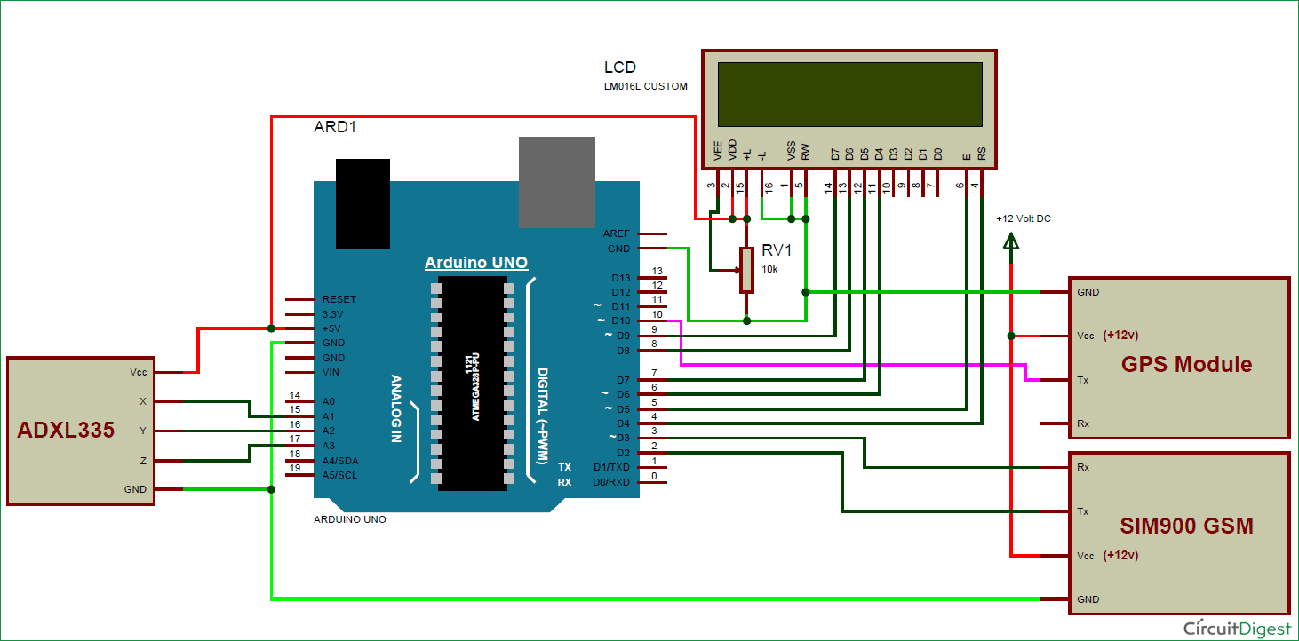

**MICROCONTROLLER**

**MICROCONTROLLER**

Microcontrollers are destined to play an increasingly important role in revolutionizing various industries and influencing our day to day life more strongly than one can imagine. Since its emergence in the early 1980's the microcontroller has been recognized as a general purpose building block for intelligent digital systems. It is finding using diverse area, starting from simple children's toys to highly complex spacecraft. Because of its versatility and many advantages, the application domain has spread in all conceivable directions, making it ubiquitous.

As a consequence, it has generate a great deal of interest and enthusiasm among students, teachers and practicing engineers, creating an acute education need for imparting the knowledge of microcontroller based system design and development. It identifies the vital features responsible for their tremendous impact, the acute educational need created by them and provides a glimpse of the major application area.

A microcontroller is a complete microprocessor system built on a single IC. Microcontrollers were developed to meet a need for microprocessors to be put into low cost products. Building a complete microprocessor system on a single chip substantially reduces the cost of building simple products, which use the microprocessor's power to implement their function, because the microprocessor is a natural way to implement many products. This means the idea of using a microprocessor for low cost products comes up often. But the typical 8-bit microprocessor based system, such as one using a Z80 and 8085 is expensive. Both 8085 and Z80 system need some additional circuits to make a microprocessor system.

Each part carries costs of money. Even though a product design may requires only very simple system, the parts needed to make this system as a low cost product.

To solve this problem microprocessor system is implemented with a single chip microcontroller. This could be called microcomputer, as all the major parts are in the IC. Most frequently they are called microcontroller because they are used they are used to perform control functions.

The block diagram of microcontroller as shown in figure3.The microcontroller contains full implementation of a standard MICROPROCESSOR, ROM, RAM, I/0, CLOCK, TIMERS, and also SERIALPORTS. Microcontroller also called "system on a chip" or "single chip microprocessor system" or "computer on a chip".

A pin diagram of microcontroller as shown in figure4.A microcontroller is a Computer-On-A-Chip, or, if you prefer, a single-chip computer. Micro suggests that the device is small, and controller tells you that the device' might be used to control objects, processes, or events.

**APPLICATION**

A microcontroller is a kind of miniature computer that you can find in all kinds of Gizmos. Some examples of common, every-day products that have microcontrollers are built-in. If it has buttons and a digital display, chances are it also has a programmable microcontroller brain.

Every-Day the devices used by ourselves that contain Microcontrollers. Try to make a list and counting how many devices and the events with microcontrollers you use in a typical day.

**BLOCK DIAGRAM OF MICROCONTROLLER**

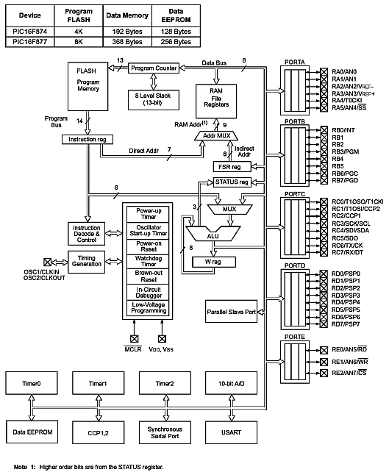

**fig NO: 01**

**ARDUINO MICROCONTROLLER**

The number of embedded devices that can interact with environment are already con-nected to internet, and it is estimated that the number reaches 50 billion by 2020 (Kouhia, 2016). The growth of such interacting objects achieved this staggering pace with the development of microcontroller based easy-to-use designed system which are replacing old systems designed with complicated electronic circuits. Arduino is a microcontroller board which functions as a tiny computer; it is a platform where creation and development of interacting objects is possible with required program-ming software.

The Arduino software IDE (Integrated Development Environment) pro-vides space to write codes in the language (programming languages C, C++) that Ar-duino board understands and responds to. Inexpensiveness, easy-to-use design and flexibility for advance modifications are some features of the microcontroller based Ar-duino hardware and software that are making its range of use wider. One of the most important factor that affects its increasing range of use is its freedom of use. Both the Arduino hardware and the software are open source. Which means that one can easily use the ideas generated by others in their work and modify them without anyone’s au-thorization. It can be used by anyone to do anything they want to do with it (Banzi, ei pvm).

Arduino boards are designed in such a way that one without prior knowledge of electronics or previous experience of programming can use information from other peo-ple’s work and build their own interactive object that can sense the environment and control it. It comes with a cheap price which is a crucial factor that makes Arduino ac-cessible to many students, hobbyists and teachers and ultimately a new revolution of innovation in electronics.



**INTRODUCTION**

Arduino is used for building different types of electronic circuits easily using of both a physical programmable circuit board usually microcontroller and piece of code running on computer with USB connection between the computer and Arduino. Programming language used in Arduino is just a simplified version of C++ that can easily replace thousands of wires with words.

**ARDUINO UNO-R3 PHYSICAL COMPONENTS**

**ATMEGA328P-PU microcontroller**

The most important element in Arduino Uno R3 is ATMEGA328P-PU is an 8-bit Microcontroller with flash memory reach to 32k bytes. It’s features as follow:

• High Performance, Low Power AVR

• Advanced RISC Architecture

o 131 Powerful Instructions – Most Single Clock Cycle Execution

o 32 x 8 General Purpose Working Registers

o Up to 20 MIPS Throughput at 20 MHz

o On-chip 2-cycle Multiplier

• High Endurance Non-volatile Memory Segments

o 4/8/16/32K Bytes of In-System Self-Programmable Flash program memory

o 256/512/512/1K Bytes EEPROM

o 512/1K/1K/2K Bytes Internal SRAM

o Write/Erase Cycles: 10,000 Flash/100,000 EEPROM

o Data retention: 20 years at 85°C/100 years at 25°C

o Optional Boot Code Section with Independent Lock Bits

o In-System Programming by On-chip Boot Program

o True Read-While-Write Operation

o Programming Lock for Software Security

• Peripheral Features

o Two 8-bit Timer/Counters with Separate Prescaler and Compare Mode

o One 16-bit Timer/Counter with Separate Prescaler, Compare Mode, and Capture Mode

o Real Time Counter with Separate Oscillator

o Six PWM Channels

o 8-channel 10-bit ADC in TQFP and QFN/MLF package

o Temperature Measurement

o 6-channel 10-bit ADC in PDIP Package

o Temperature Measurement

o Programmable Serial USART

o Master/Slave SPI Serial Interface

o Byte-oriented 2-wire Serial Interface (Philips I2 C compatible)

o Programmable Watchdog Timer with Separate On-chip Oscillator

o On-chip Analog Comparator

o Interrupt and Wake-up on Pin Change

• Special Microcontroller Features

o Power-on Reset and Programmable Brown-out Detection

o Internal Calibrated Oscillator

o External and Internal Interrupt Sources

o Six Sleep Modes: Idle, ADC Noise Reduction, Power-save, Power-down, Standby, and Extended Standby

• I/O and Packages

o 23 Programmable I/O Lines

o 28-pin PDIP, 32-lead TQFP, 28-pad QFN/MLF and 32-pad QFN/MLF

• Operating Voltage:

o 1.8 - 5.5V

• Temperature Range:

o -40°C to 85°C

• Speed Grade:

o 0 - 4 MHz@1.8 - 5.5V, 0 - 10 MHz@2.7 - 5.5.V, 0 - 20 MHz @ 4.5 - 5.5V

• Power Consumption at 1 MHz, 1.8V, 25°C

o Active Mode: 0.2 mA

o Power-down Mode: 0.1 μA

o Power-save Mode: 0.75 μA (Including 32 kHz RTC)

**INPUT Digital**

An electronic signal transmitted as binary code that can be either the presence or absence of

current, high and low voltages or short pulses at a particular frequency. Humans perceive the world in analog, but robots, computers and circuits use Digital. A digital signal is a signal that has only two states. These states can vary depending on the signal, but simply defined the states are ON or OFF, never in between. In the world of Arduino, Digital signals are used for everything with the exception of Analog Input. Depending on the voltage of the Arduino the ON or HIGH of the Digital signal will be equal to the system voltage, while the OFF or LOW signal will always equal 0V. This is a fancy way of saying that on a 5V Arduino the HIGH signals will be a little under 5V and on a 3.3V Arduino the HIGH signals will be a little under 3.3V. To receive or send Digital signals the Arduino uses Digital pins # 0 - # 13. You may also setup your

**INPUT Analog**

pins to act as Digital pins. To set up Analog In pins as Digital pins use the

command: pinMode(pinNumber, value);

where pinNumber is an Analog pin (A0 – A5) and value is either INPUT or OUTPUT. To setup Digital pins use the same command but reference a Digital pin for pinNumber instead of an Analog In pin. Digital pins default as input, so really you only need to set them to OUTPUT in pinMode. To read these pins use the command: digitalRead(pinNumber); where pinNumber is the Digital pin to which the Digital component is connected. The digitalRead command will return either a HIGH or a LOW signal. To send a Digital signal to a pin use the command: digitalWrite(pinNumber, value); where pinNumber is the number of the pin sending the signal and value is either HIGH or LOW. The Arduino also has the capability to output a Digital signal that acts as an Analog signal, this signal is called Pulse Width Modulation (PWM). Digital Pins # 3, # 5, # 6, # 9, # 10 and #11 have PWM capabilities. To output a PWM signal use the command: analogWrite(pinNumber, value); where pinNumber is a Digital Pin with PWM capabilities and value is a number between 0 (0%) and 255 (100%). For more information on PWM see the PWM worksheets or S.I.K. circuit 12. Examples of Digital: Values: On/Off, Men’s room/Women’s room, pregnancy, consciousness, the list goes on.... Sensors/Interfaces: Buttons, Switches, Relays, CDs, etc.... Things to remember about Digital:

• Digital Input/Output uses the Digital pins, but Analog In pins can be used as Digital

• To receive a Digital signal use: digitalRead(pinNumber);

• To send a Digital signal use: digitalWrite(pinNumber, value);

• Digital Input and Output are always either HIGH or LOW

**INPUT Analog**

A continuous stream of information with values between and including 0% and 100%. Humans perceive the world in analog. Everything we see and hear is a continuous transmission of information to our senses. The temperatures we perceive are never 100% hot or 100% cold, they are constantly changing between our ranges of acceptable temperatures. This continuous stream is what defines analog data. Digital information, the complementary concept to Analog, estimates analog data using only ones and zeros. In the world of Arduino an Analog signal is simply a signal that can be HIGH (on), LOW (off) or anything in between these two states. This means an Analog signal has a voltage value that can be anything between 0V and 5V (unless you mess with the Analog Reference pin). Analog allows you to send output or receive input about devices that run at percentages as well as on and off. The Arduino does this by sampling the voltage signal sent to these pins and comparing it to a voltage reference signal (5V). Depending on the voltage of the Analog signal when compared to the Analog Reference signal the Arduino then assigns a numerical value to the signal somewhere between 0 (0%) and 1023 (100%). The digital system of the Arduino can then use this number in calculations and sketches. To receive Analog Input the Arduino uses Analog pins # 0 - # 5. These pins are designed for use with components that output Analog information and can be used for Analog Input. There is no setup necessary, and to read them use the command: analog Read(pin Number); where pin Number is the Analog In pin to which the the Analog component is connected. The analogRead command will return a number including or between 0 and 1023. The Arduino also has the capability to output a digital signal that acts as an Analog signal, this signal is called Pulse Width Modulation (PWM). Digital Pins # 3, # 5, # 6, # 9, # 10 and #11 have PWM capabilities. To output a PWM signal use the command: nalogWrite(pinNumber, value); where pinNumber is a Digital Pin with PWM capabilities and value is a number between 0 (0%) and 255 (100%). On the Arduino UNO PWM pins are signified by a ~ sign. For more information on PWM see the PWM worksheets or S.I.K. circuit 12.

Examples of Analog:

Values: Temperature, volume level, speed, time, light, tide level, spiciness, the list goes on.... Sensors: Temperature sensor, Photo resistor, Microphone, Turntable, Speedometer, etc....

Things to remember about Analog:

• Analog Input uses the Analog In pins, Analog Output uses the PWM pins

• To receive an Analog signal use: analog Read(pin Number);

• To send a PWM signal use: analog Write(pin Number, value);

• Analog Input values range from 0 to 1023 (1024 values because it uses 10 bits, 210)

• PWM Output values range from 0 to 255 (256 values because it uses 8 bits, 28)

**OUTPUT SIGNALS**

A signal exiting an electrical system, in this case a microcontroller. Output to the Arduino pins is always Digital, however there are two different types of Digital Output; regular Digital Output and Pulse Width Modulation Output (PWM). Output is only possible with Digital pins # 0 - # 13. The Digital pins are preset as Output pins, so unless the pin was used as an Input in the same sketch, there is no reason to use the pin Mode command to set the pin as an Output. Should a situation arise where it is necessary to reset a Digital pin to Output from Input use the command: pin Mode(pin Number, OUTPUT); where pin Number is the Digital pin number set as Output. To send a Digital Output signal use the command: digital Write(pin Number, value); where pin Number is the Digital pin that is outputting the signal and value is the signal. When outputting a Digital signal value can be either HIGH (On) or LOW (Off). Digital Pins # 3, # 5, # 6, # 9, # 10 and #11 have PWM capabilities. This means you can Output the Digital equivalent of an Analog signal using these pins. To Output a PWM signal use the command:

analog Write(pin Number, value); where pin Number is a Digital Pin with PWM capabilities and value is a number between 0 (0%) and 255 (100%). For more information on PWM see the PWM worksheets or S.I.K. circuit 12. Output can be sent to many different devices, but it is up to the user to figure out which kind of Output signal is needed, hook up the hardware and then type the correct code to properly use these signals. Things to remember about Output:

• Output is always Digital

• There are two kinds of Output: regular Digital or PWM (Pulse Width Modulation)

• To send an Output signal use analog Write(pin Number, value); (for analog) or

digital Write(pin Number, value); (for digital)

• Output pin mode is set using the pin Mode command: pin Mode(pin Number, OUTPUT);

• Regular Digital Output is always either HIGH or LOW

• PWM Output varies from 0 to 255

**OSCILLATOR AND CLOCK CIRCUIT:**

XTAL1 and XTAL2 are the input and output respectively of an inverting amplifier which is intended for use as a crystal oscillator in the pierce configuration, in the frequency range of 1.2 MHz to 12 Mhz. XTAL2 also the input to the internal clock generator oscillator circuit diagram as shown in figure 5.To drive the chip with an internal oscillator, one would ground XTAL1 and XTAL2. Since the input to the.

clock generator is dividing by two flip flop there are no requirements on the duty cycle of the external oscillator signal. However, minimum high and low times must be observed.

**OSCILLATOR CIRCUIT**

C1

C2

**FIG NO: 05**

The clock generator divides the oscillator frequency by 2 and provides a tow phase clock signal to the chip. Ceramic resonators may be used as low-cost alternative to crystal resonators. However, decreases in frequency stability data accuracy make the ceramic resonator a poor choice if high-speed serial data communication with the systems, or critical timing, is to be done.

The oscillator formed by the crystal, capacitors, and an on-chip inverter microcontroller, called the pulse, P, time. The smallest interval of time to accomplish any simple instruction, or part of a complex instruction, however, is the machine cycle. The machine cycle is itself made up of six states. A state is the basic time interval for discrete operations of the microcontroller such as fetching an opcode byte, decoding an opcode, executing an opcode, or writing a data byte. Two oscillator pulses define each state.

The time to execute that instruction is then found by multiplying C by 12 and dividing the product by the crystal frequency:

|  |
| --- |
| C x 12  T inst = -------------------------------------------  Crystal frequency |

**FIG.NO:06**

**ACCELEROMETER SENSOR**

An accelerometer is an electronic [sensor](https://www.fierceelectronics.com/sensors/what-a-sensor) that measures the acceleration forces acting on an object, in order to determine the object’s position in space and monitor the object’s movement. Acceleration, which is a [vector quantity](https://www.physicsclassroom.com/Class/1DKin/U1L1b.cfm), is the rate of change of an object’s velocity (velocity being the [displacement of the object divided by the change in time](https://www.khanacademy.org/science/physics/one-dimensional-motion/displacement-velocity-time/v/calculating-average-velocity-or-speed)).

There are two types of acceleration forces: static forces and dynamic forces. Static forces are forces that are constantly being applied to the object (such as friction or gravity). Dynamic forces are “moving” forces applied to the object at various rates (such as [vibration](https://www.sciencedirect.com/topics/engineering/dynamic-force), or the force exerted on a cue ball in a game of pool). This is why accelerometers are used in automobile collision safety systems, for example. When a car is acted on by a powerful dynamic force, the accelerometer (sensing a rapid deceleration) sends an electronic signal to an [embedded computer](https://www.fierceelectronics.com/embedded/what-embedded-computer), which in turn deploys the airbags.

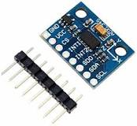

There are three different types of accelerometers, and they are each designed to efficiently function in their intended environments. The three types are: piezoelectric, piezoresistance and capacitive.

A [piezoelectric accelerometer](https://www.azosensors.com/article.aspx?ArticleID=309) utilizes the [piezoelectric effect](https://www.electronicdesign.com/power/what-piezoelectric-effect) (piezoelectric materials produce electricity when put under physical stress) to sense change in acceleration. Piezoelectric accelerometers are most commonly used in [vibration and shock measurement](https://blog.mide.com/piezoelectric-accelerometers-how-they-work-and-where-to-buy).

Piezoresistance accelerometers are much less sensitive than piezoelectric accelerometers, and they are better suited to [vehicle crash testing](https://blog.mide.com/accelerometer-selection). A piezoresistance accelerometer [increases its resistance](https://www.electronicdesign.com/components/what-s-difference-between-piezoelectric-and-piezoresistive-components) in proportion to the amount of pressure applied to it.

The third and most commonly used type of accelerometer is the capacitive accelerometer. Capacitive accelerometers use [change in electrical capacitance](http://www.sensorland.com/HowPage011.html) to determine an object’s acceleration. When the sensor undergoes acceleration, the distance between its capacitor plates changes as the diaphragm of the sensor moves.

Most accelerometers are miniscule, and they are often referred to as Micro-Electro-Mechanical Systems (MEMS) accelerometers. Because of their size and affordability, they are embedded in a myriad of hand-held electronic devices (such as phones, tablets, and video game controllers). In phones and tablets, the accelerometer is responsible for “flipping” the screen when the device is rotated. Accelerometers are also used by zoologists (to track the movement of animals in the wild), engineers (especially in collision experiments) and factories (to monitor the vibration of machinery).

**GSM MODEM**

**GSM** (**Global System for Mobile communications**: originally from **Groupe Spécial Mobile**) is the most popular standard for [mobile phones](http://en.wikipedia.org/wiki/Mobile_phone) in the world. Its promoter, the [GSM Association](http://en.wikipedia.org/wiki/GSM_Association), estimates that 80% of the global mobile market uses the standard. GSM is used by over 3 [billion](http://en.wikipedia.org/wiki/1000000000_(number)) people across more than 212 countries and territories. Its ubiquity makes international [roaming](http://en.wikipedia.org/wiki/Roaming) very common between[mobile phone operators](http://en.wikipedia.org/wiki/Mobile_phone_operator), enabling subscribers to use their phones in many parts of the world. GSM differs from its predecessors in that both signaling and speech channels are [digital](http://en.wikipedia.org/wiki/Digital), and thus is considered asecond generation ([2G](http://en.wikipedia.org/wiki/2G)) mobile phone system. This has also meant that data communication was easy to build into the system.

ChipSilicon is continuously introducing cutting-edge technologies in its products to achieve lower costs, better quality and competitive advantage.  
ChipSilicon is now offering GSM based hardware and software development services. This include embedded GSM terminals, GSM modems, GSM module integration, GPRS communication integration, GSM based remote monitoring and management systems, GSM applications in Industrial control, GSM security systems and more.

In your company is explore such integration with existing products or development of new products you can contact us at e-mail

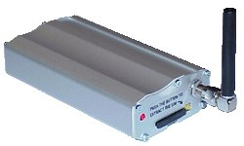

GSM (Global System for Mobile Communications) is worlds most famous Mobile platform. Mobile phones with SIM cards use GSM technology to help you communicate with your family, friends and business associates.  
GSM systems have following advantages over basic land line telephony systems:

1. Mobility  
2. Easy availability  
3. High uptime

GSM technology is being mostly used for talking to family, friends and business colleagues. we use communication feature of Telephone landlines for internet, e-mail, data connectivity, remote monitoring, computer to computer communication, security systems. In the same way we can use GSM technology and benefit from its advantages.

**You can use GSM technology for following applications:**  
**Access control devices:** Now access control devices can communicate with servers and security staff through SMS messaging. Complete log of transaction is available at the head-office Server instantly without any wiring involved and device can instantly alert security personnel on their mobile phone in case of any problem. BioEnable is introducing this technology in all Fingerprint Access control and time attendance products. You can achive high security any reliability.  
  
**Transaction terminals:** EDC machines, POS terminals can use SMS messaging to confirm transactions from central servers. The main benefit is that central server can be anywhere in the world. Today you need local servers in every city with multiple telephone lines. You save huge infrastructure costs as well as per transaction cost.

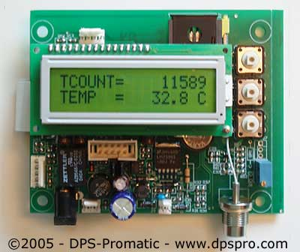

**Supply Chain Management:** Today SCM require huge IT infrastructure with leased lines, networking devices, data centre, workstations and still you have large downtimes and high costs. You can do all this at a fraction of the cost with GSM M2M technology. A central server in your head office with GSM capability is the answer, you can receive instant transaction data from all your branch offices, warehouses and business associates with nil downtime and low cost.

**What applications is suitable for GSM communication?** If your application needs one or more of the following features, GSM will be more cost-effective then other communication systems.  
**Short Data Size:** You data size per transaction should be small like 1-3 lines. e.g. banking transaction data, sales/purchase data, consignment tracking data, updates. These small but important transaction data can be sent through SMS messaging which cost even less then a local telephone call or sometimes free of cost worldwide. Hence with negligible cost you are able to send critical information to your head office located anywhere in the world from multiple points. You can also transfer faxes, large data through GSM but this will be as or more costly compared to landline networks.

**Multiple remote data collection points:**If you have multiple data collections points situated all over your city, state, country or worldwide you will benefit the most. The data can be sent from multiple points like your branch offices, business associates, warehouses, agents with devices like GSM modems connected to PCs, GSM electronic terminals and Mobile phones. Many a times some places like warehouses may be situated at remote location may not have landline or internet but you will have GSM network still available easily.

**High uptime:** If your business require high uptime and availability GSM is best suitable for you as GSM mobile networks have high uptime compared to landline, internet and other communication mediums. Also in situations where you expect that someone may sabotage your communication systems by cutting wires or taping landlines, you can depend on GSM wireless communication.

**Large transaction volumes:** GSM SMS messaging can handle large number of transaction in a very short time. You can receive large number SMS messages on your server like e-mails without internet connectivity. E-mails normally get delayed a lot but SMS messages are almost instantaneous for instant transactions. consider situation like shop owners doing credit card transaction with GSM technology instead of conventional landlines. many a time you find local transaction servers busy as these servers use multiple telephone lines to take care of multiple transactions, whereas one GSM connection is enough to handle hundreds of transaction per minute.

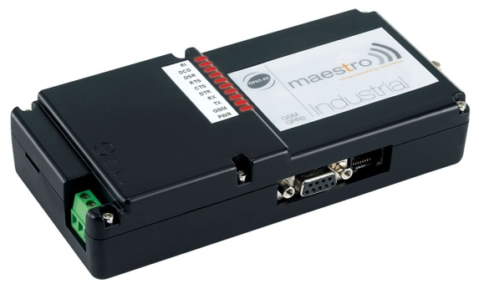

**Mobility, Quick installation:** GSM technology allow mobility, GSM terminals, modems can be just picked and installed at other location unlike telephone lines. Also you can be mobile with GSM terminals and can also communicate with server using your mobile phone. You can just purchase the GSM hardware like modems, terminals and mobile handsets, insert SIM cards, configure software and your are ready for GSM communication. GSM solutions can be implemented within few weeks whereas it may take many months to implement the infrastructure for other technologies.

**GLOBAL POSITIONING SYSTEM (GPS)**

[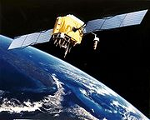](http://en.wikipedia.org/wiki/File:GPS_Satellite_NASA_art-iif.jpg)

The **Global Positioning System (GPS)** is a [Global Navigation Satellite System](http://en.wikipedia.org/wiki/Global_Navigation_Satellite_System) (GNSS) developed by the[United States Department of Defense](http://en.wikipedia.org/wiki/United_States_Department_of_Defense). It is the only fully functional GNSS in the world. It uses a [constellation](http://en.wikipedia.org/wiki/Satellite_constellation" \o "Satellite constellation)of between 24 and 32 [Medium Earth Orbit](http://en.wikipedia.org/wiki/Medium_Earth_Orbit) [satellites](http://en.wikipedia.org/wiki/Satellite) that transmit precise [microwave](http://en.wikipedia.org/wiki/Microwave) signals, which enable GPS [receivers](http://en.wikipedia.org/wiki/Receiver_(radio)) to determine their current [location](http://en.wikipedia.org/wiki/Geographic_location), the time, and their velocity. Its official name is **NAVSTAR GPS**. Although NAVSTAR is not an acronym,[[1]](http://en.wikipedia.org/wiki/Gps#cite_note-0#cite_note-0) a few [backronyms](http://en.wikipedia.org/wiki/Backronym) have been created for it.[[2]](http://en.wikipedia.org/wiki/Gps#cite_note-1#cite_note-1) The GPS satellite constellation is managed by the [United States Air Force](http://en.wikipedia.org/wiki/United_States_Air_Force) [50th Space Wing](http://en.wikipedia.org/wiki/50th_Space_Wing). GPS is often used by civilians as a navigation system.

After [Korean Air Lines Flight 007](http://en.wikipedia.org/wiki/Korean_Air_Lines_Flight_007) was shot down in 1983 after straying into the USSR's [prohibited airspace](http://en.wikipedia.org/wiki/Prohibited_airspace),[[3]](http://en.wikipedia.org/wiki/Gps#cite_note-2#cite_note-2)President [Ronald Reagan](http://en.wikipedia.org/wiki/Ronald_Reagan) issued a directive making GPS freely available for civilian use as a common good.[[4]](http://en.wikipedia.org/wiki/Gps#cite_note-KAL007-3#cite_note-KAL007-3) Since then, GPS has become a widely used [aid to navigation](http://en.wikipedia.org/wiki/Radio_navigation) worldwide, and a useful tool for [map-making](http://en.wikipedia.org/wiki/Cartography), [land surveying](http://en.wikipedia.org/wiki/Surveying), commerce, scientific uses, and hobbies such as [geocaching](http://en.wikipedia.org/wiki/Geocaching). Also, the precise [time reference](http://en.wikipedia.org/wiki/Time_transfer) is used in many applications including the scientific study of [earthquakes](http://en.wikipedia.org/wiki/Earthquake). GPS is also a required key [synchronization](http://en.wikipedia.org/wiki/Synchronization) resource of cellular networks, such as the Qualcomm CDMA air interface used by many wireless carriers in a multitude of countries.

[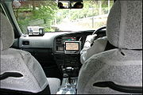](http://en.wikipedia.org/wiki/File:KyotoTaxiRide.jpg)

[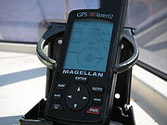](http://en.wikipedia.org/wiki/File:Magellan_GPS_Blazer12.jpg)

The first satellite navigation system, [Transit](http://en.wikipedia.org/wiki/Transit_(satellite)), used by the [United States Navy](http://en.wikipedia.org/wiki/United_States_Navy), was first successfully tested in 1960. Using a constellation of five satellites, it could provide a navigational fix approximately once per hour. In 1967, the U.S. Navy developed the [Timation](http://en.wikipedia.org/wiki/Timation" \o "Timation) satellite which proved the ability to place accurate clocks in space, a technology that GPS relies upon. In the 1970s, the ground-based [Omega Navigation System](http://en.wikipedia.org/wiki/Omega_Navigation_System), based on signal phase comparison, became the first worldwide radio navigation system. The design of GPS is based partly on similar ground-based radio navigation systems, such as [LORAN](http://en.wikipedia.org/wiki/LORAN) and the [Decca Navigator](http://en.wikipedia.org/wiki/Decca_Navigator_System)developed in the early 1940s, and used during [World War II](http://en.wikipedia.org/wiki/World_War_II). Additional inspiration for the GPS came when the [Soviet Union](http://en.wikipedia.org/wiki/Soviet_Union) launched the first [Sputnik](http://en.wikipedia.org/wiki/Sputnik_program) in 1957.

A team of U.S. scientists led by Dr. Richard B. Kershner were monitoring Sputnik's radio transmissions. They discovered that, because of the [Doppler effect](http://en.wikipedia.org/wiki/Doppler_effect), the frequency of the signal being transmitted by Sputnik was higher as the satellite approached, and lower as it continued away from them. They realized that since they knew their exact location on the globe, they could pinpoint where the satellite was along its orbit by measuring the Doppler distortion.

* **BASIC CONCEPT OF GPS**

A GPS receiver calculates its position by carefully timing the signals sent by the GPS [satellites](http://en.wikipedia.org/wiki/Satellites) high above the Earth. Each satellite continually transmits messages containing the time the message was sent, precise orbital information (the [ephemeris](http://en.wikipedia.org/wiki/Ephemeris)), and the general system health and rough orbits of all GPS satellites (the almanac). The receiver measures the transit time of each message and computes the distance to each satellite. Geometric [trilateration](http://en.wikipedia.org/wiki/Trilateration) is used to combine these distances with the location of the satellites to determine the receiver's location. The position is displayed, perhaps with a moving map display or latitude and longitude; elevation information may be included. Many GPS units also show derived information such as direction and speed, calculated from position changes.

It might seem three satellites are enough to solve for position, since space has three dimensions. However a very small clock error multiplied by the very large [speed of light](http://en.wikipedia.org/wiki/Speed_of_light)—the speed at which satellite signals propagate—results in a large positional error. The receiver uses a fourth satellite to solve for *x*, *y*, *z*, and *t* which is used to correct the receiver's clock. While most GPS applications use the computed location only and effectively hide the very accurately computed time, it is used in a few specialized GPS applications such as [time transfer](http://en.wikipedia.org/wiki/Time_transfer) and traffic signal timing.

Although four satellites are required for normal operation, fewer apply in special cases. If one variable is already known (for example, a ship or plane may have known elevation), a receiver can determine its position using only three satellites. Some GPS receivers may use additional clues or assumptions (such as reusing the last known altitude, [dead reckoning](http://en.wikipedia.org/wiki/Dead_reckoning), , or including information from the vehicle computer) to give a degraded position when fewer than four satellites are visible (see [[6]](http://en.wikipedia.org/wiki/Gps#cite_note-5#cite_note-5), Chapters 7 and 8 of [[7]](http://en.wikipedia.org/wiki/Gps#cite_note-NAVGPS-6#cite_note-NAVGPS-6), and [[8]](http://en.wikipedia.org/wiki/Gps#cite_note-7#cite_note-7)).

* **Position calculation introduction**

To provide an introductory description of how a GPS receiver works, measurement errors will be ignored in this section. Using messages received from a minimum of four visible satellites, a GPS receiver is able to determine the satellite positions and time sent. The x, y, and z components of position and the time sent are designated as \left [x_i, y_i, z_i, t_i\right ] where the subscript *i* is the satellite number and has the value 1, 2, 3, or 4. Knowing the indicated time the message was received \  tr_i, the GPS receiver can compute the indicated transit time, \left (tr_i-t_i\right ) . of the message. Assuming the message traveled at the speed of light, [c](http://en.wikipedia.org/wiki/C), the distance traveled, \  p_i can be computed as \left (tr_i-t_i\right )c . Knowing the distance from GPS receiver to a satellite and the position of a satellite implies that the GPS receiver is on the surface of a sphere centered at the position of a satellite. Thus we know that the indicated position of the GPS receiver is at or near the intersection of the surfaces of four spheres. In the ideal case of no errors, the GPS receiver will be at an intersection of the surfaces of four spheres. The surfaces of two spheres, if they intersect in more than one point, intersect in a circle. A figure, *Two Sphere Surfaces Intersecting in a Circle*, is shown below. Two points at which the surfaces of the spheres intersect are clearly shown in the figure. The distance between these two points is the diameter of the circle of intersection.

[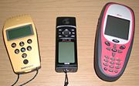](http://en.wikipedia.org/wiki/File:GPS_Receivers.jpg)

**BUZZER**

[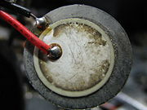](http://en.wikipedia.org/wiki/Image:2007-07-24_Piezoelectric_buzzer.jpg)

A **buzzer** or **beeper** is a signaling device, usually electronic, typically used in [automobiles](http://en.wikipedia.org/wiki/Automobile), household appliances such as a [microwave oven](http://en.wikipedia.org/wiki/Microwave_oven), or [game shows](http://en.wikipedia.org/wiki/Game_show).

It most commonly consists of a number of [switches](http://en.wikipedia.org/wiki/Switch) or [sensors](http://en.wikipedia.org/wiki/Sensor) connected to a control unit that determines if and which button was pushed or a preset time has lapsed, and usually illuminates a light on the appropriate button or control panel, and sounds a warning in the form of a continuous or intermittent buzzing or beeping [sound](http://en.wikipedia.org/wiki/Sound). Initially this device was based on an electromechanical system which was identical to an [electric bell](http://en.wikipedia.org/wiki/Electric_bell) without the metal gong (which makes the ringing noise). Often these units were anchored to a wall or ceiling and used the ceiling or wall as a sounding board. Another implementation with some AC-connected devices was to implement a circuit to make the AC current into a noise loud enough to drive a loudspeaker and hook this circuit up to a cheap 8-ohm speaker. Nowadays, it is more popular to use a ceramic-based [piezoelectric](http://en.wikipedia.org/wiki/Piezoelectric) sounder like a Sonalert which makes a high-pitched tone. Usually these were hooked up to "driver" circuits which varied the pitch of the sound or pulsed the sound on and off.

In game shows it is also known as a "lockout system," because when one person signals ("buzzes in"), all others are locked out from signalling. Several game shows have large buzzer buttons which are identified as "plungers".The word "buzzer" comes from the rasping noise that buzzers made when they were electromechanical devices, operated from stepped-down AC line voltage at 50 or 60 cycles. Other sounds commonly used to indicate that a button has been pressed are a ring or a beep.

Some systems, such as the one used on [*Jeopardy!*](http://en.wikipedia.org/wiki/Jeopardy%21), make no noise at all, instead using light. Another example is the buzzer at the end of each stage in [Sasuke](http://en.wikipedia.org/wiki/Sasuke_%28TV_series%29), [Kunoichi](http://en.wikipedia.org/wiki/Kunoichi_%28TV_series%29), and [Viking](http://en.wikipedia.org/wiki/Viking:_The_Ultimate_Obstacle_Course). These buzzers do not make a sound or turn on a light; instead, they stop a nearby digital clock, briefly fire two smoke cannons on each side of the stage exit, and open the exit. However, at the end of the Heartbreaker in Viking, the buzzer is replaced with a sword that, when removed, causes two contacts to touch, closing the circuit and causing the latter two actions above to occur.

Nowadays some people use the word "buzzer" as to describe a person who's able to create a big buzz around a brand, an event or a company

**Piezoelectricity** is the ability of some materials (notably [crystals](http://en.wikipedia.org/wiki/Crystal) and certain [ceramics](http://en.wikipedia.org/wiki/Ceramic)) to generate an [electric potential](http://en.wikipedia.org/wiki/Electric_potential)[[1]](http://en.wikipedia.org/wiki/#_note-InstrumentAnalysis) in response to applied mechanical [stress](http://en.wikipedia.org/wiki/Stress_%28physics%29). This may [take the form](http://en.wikipedia.org/wiki/Piezoelectricity#Crystal_classes) of a separation of [electric charge](http://en.wikipedia.org/wiki/Electric_charge) across the [crystal lattice](http://en.wikipedia.org/wiki/Crystal_lattice). If the material is not [short-circuited](http://en.wikipedia.org/wiki/Short_circuit), the applied charge induces a [voltage](http://en.wikipedia.org/wiki/Voltage) across the material. The word is derived from the [Greek](http://en.wikipedia.org/wiki/Greek_language) *piezein*, which means to squeeze or press.

The piezoelectric effect is reversible in that materials exhibiting the *direct piezoelectric effect* (the production of electricity when stress is applied) also exhibit the *converse piezoelectric effect* (the production of stress and/or [strain](http://en.wikipedia.org/wiki/Strain_%28materials_science%29) when an electric field is applied). For example, [lead zirconate titanate](http://en.wikipedia.org/wiki/Lead_zirconate_titanate) crystals will exhibit a maximum shape change of about 0.1% of the original dimension.

The effect finds useful applications such as the production and detection of sound, generation of high voltages, electronic frequency generation, [microbalances](http://en.wikipedia.org/wiki/Microbalance), and ultra fine focusing of optical assemblies. It is also the basis of a number of scientific instrumental techniques with atomic resolution, the [*scanning probe microscopies*](http://en.wikipedia.org/wiki/Scanning_probe_microscopy) such as [STM](http://en.wikipedia.org/wiki/Scanning_tunnelling_microscopy), [AFM](http://en.wikipedia.org/wiki/Atomic_force_microscopy), [MTA](http://en.wikipedia.org/wiki/Microthermal_analysis), [SNOM](http://en.wikipedia.org/wiki/Scanning_near-field_optical_microscopy) etc.

**LCD DISPLAY**

**INTRODUCTION**

LCD stands for liquid crystal display this is a output device with a limited viewing angle. The choice of LCD as an output device because of its cost of use and is better with alphabets when compared with a 7-segment LED display. One can have so many kinds of LCD today and our application requires a LCD with 2 lines and 16 characters per line, this gets data from the microcontroller and displays the same. It has 8 data lines, 3 control line, a supply voltage Vcc (+5v and a GND. This makes the whole device user friendly by showing the balance left in the card. This also shoes the card that is currently being used.

In recent years the LCD is finding widespread use replacing LED’s. This is due to the following reasons:

1. The declining prices of LCD’s.
2. The ability to display numbers, characters and graphics. This is in contrast to LED’s, which are limited to numbers and few characters.
3. Incorporation of a refreshing controller into the LCD, there by relieving the CPU of the task of refreshing the LCD .in contrast, the Led must be refreshed by the CPU to keep displaying the data.
4. Ease of programming for characters and graphics.

**LCD PIN DESCRIPTION**

**VCC, VSS and VEE**

While VCC and VSS provide +5v and ground respectively, VEE is used for controlling LCD contrast.

**RS, REGISTER SELECT**

There are two very important registers inside the LCD. The RS pin used for their selection as follows. If RS=0, the instruction command code register is selected, allowing the user to sent a command such as clear display, cursor at home ,etc .IF RS=1 the data register is selected, allowing the user to sent data to be displayed on the LCD.

**R/W (READ/WRITE)**

R/W input allows the user to write information to the LCD or read information from it.

R/W=1 when reading; R/W=0 when writing.

**E, ENABLE**

The enable pin is used by the LCD to latch information present to its data pins. When data is supplied to data pins, a high to low pulse must be applied to this pin in order for the LCD to latch in the data present at the data pins. This pulse must be a minimum of 450ns wide.

**D0-D7**

The 8-bit data pins, D0-D7, are used to sent information to LCD or read the contents of the LCD’s internal registers.

To display letters and numbers, they send ASCII codes for the letters A-Z, a-z, and numbers 0-9 to these pins while making RS=1.

There are also instruction command codes that can be send to the LCD to clear the display or force the cursor to the home position or blink the cursor.

**LCD COMMAND CODE**

|  |  |
| --- | --- |
| 1 | Clear display screen |
| 2 | Return home |
| 4 | Decrement cursor |
| 6 | Increment cursor |
| 5 | Shift display right |
| 7 | Shift display left |
| 8 | Display off, cursor off |
| A | Display off, cursor on |
| C | Display on, cursor off |
| E | Display on, cursor blinking |
| F | Display on, cursor blinking |
| 10 | Shift cursor position to left |
| 14 | Shift cursor position to right |
| 18 | Shift the entire display to the left |
| 1C | Shift the entire display to the right |
| 80 | Force cursor to beginning of the 1st line |
| C0 | Force cursor to beginning of the 2nd line |
| 38 | 2 lines and 2\*7 matrix |

Table: LCD COMMAND CODES

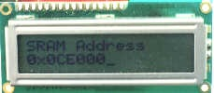

Figure: A 16x2 Liquid Crystal Display

**POWER SUPPLY**

Available power source is an Ac voltage arrives at 230V.Since our electronic circuits require only very minimum voltage and current. One can use step down power transformer. Step down transformer is designed in such a way that the input is 230V and output of 12V. Another thing is, that electronic circuits operate in DC where as available output of transformer is Ac of 12V. So rectifier circuit is used to convert AC to DC. Rectifier circuit consists of four diodes formed in bridge fashion so as to convert incoming AC to DC.

Even though the circuit is functioning with 5V, the relays are driven by 6V or 12V. For this purpose 7806/7812 regulator IC is additionally connected to the rectifier filter circuit. Thus 12V regulated is used for driving 12V relays.

**VOLTAGE REGULATORS**

**THREE-TERMINAL REGULATORS**

For most no critical applications the best choice for a voltage regulator is the simple –terminal type. It has only three connections (input, output, and ground) and is factory-trimmed to provide a fixed output. Typical of this type is the 78xx. The voltage is specified by the last two digits of the part number and can be any of the following: 05, 08,10, 12, 15,18, or 24. It is to make a +5 volt regulator, for instance, with one of these regulators. The capacitor across the output improves transient response and keeps the impedance low at high frequencies (an input capacitor of at least 0.33μF should be used in addition if the regulator is located a considerable distance from the filter capacitors).

The 7800 series is available in plastic or metal power packages (same as power transistors). A low-power version, the 78Lxx, comes in the same plastic and metal packages as small-signal transistors. The 7900 series of negative regulators works the same way (with negative input voltage, of course). The 7800 series can provide up to 1 amp load current and has on-chip circuitry to prevent damage in the event of overheating or excessive load current; the chip simply shuts down, rather than blowing out. In addition, on-chip circuitry prevents operation outside the Transistor safe operating area by reducing available output current for large input-output voltage differential. These regulators are in-expensive and easy to use, and they make it practical to design a system with many printed-circuit boards in which the unregulated dc is brought to each board and regulation is done locally on each circuit card.

Three - terminal fixed regulators come in some highly useful variants. The LP 2950 works just like a 7805, but draws only 75μA of quiescent current (compared with the 7805’s 5mA or the 78L05’s 3mA); it also regulates with as little as a 0.4 volt drop from unregulated input to regulated output (called the “drop out voltage”), compared with 2 volts drop out for the classic 7805. The LM291 is also low-dropout, but they might call it milli power (0.4mA quiescent current), compared with the “micro power” LP 2950. Low-dropout regulators also come in high – current versions for example, the LT 1085/4/3 series from LTC (A, 5A, and 7.5A, respectively, with both + 5V and + 12V available in each type). Regulators like the LM 2984 are basically three-terminal fixed regulators, but with extra outputs to signal a microprocessor that power has failed, or resumed. Finally, regulators like the 4195 contain a pair of 3-terminal 15-volt regulators, one positive and one negative.

**LM78XX Series Voltage Regulators**

**CIRCUIT DIAGRAM OF POWER SUPPLY UNIT**



Figure: CIRCUIT DIAGRAM OF POWER SUPPLY UNIT

**SOFTWARE TOOLS**

**SOFTWARE DESCRIPTIONS**

**3.1 ARDUINO IDE**

ARDUINO IDE

Arduino IDE: Initial Setup

This is the Arduino IDE once it’s been opened. It opens into a blank sketch where you can start programming immediately. First, we should configure the board and port settings to allow us to upload code. Connect your Arduino board to the PC via the USB cable.

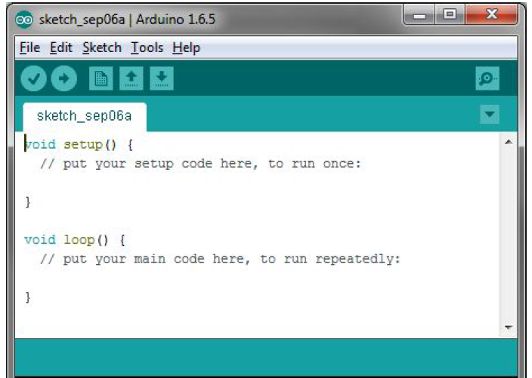

**IDE: Board Setup**

You have to tell the Arduino IDE what board you are uploading to. Select the **Tools** pulldown menu and go to **Board.** This list is populated by default with the currently available Arduino Boards that are developed by Arduino. If you are using an Uno or an Uno-Compatible Clone (ex. Funduino, SainSmart, IEIK, etc.), select Arduino Uno. If you are using another board/clone, select that board.

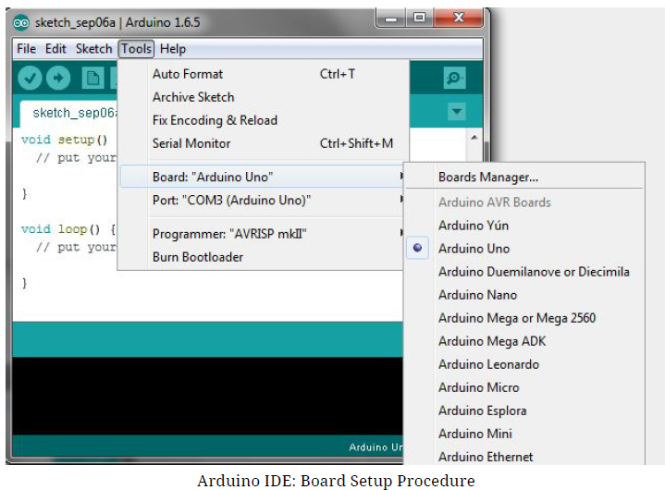

**IDE: COM Port Setup**

If you downloaded the Arduino IDE before plugging in your Arduino board, when you plugged in the board, the USB drivers should have installed automatically. The most recent Arduino IDE should recognize connected boards and label them with which COM port they are using. Select the **Tools** pulldown menu and then **Port.** Here it should list all open COM ports, and if there is a recognized Arduino Board, it will also give it’s name. Select the Arduino board that you have connected to the PC. If the setup was successful, in the bottom right of the Arduino IDE, you should see the board type and COM number of the board you plan to program. Note: the Arduino Uno occupies the next available COM port; it will not always be COM3.

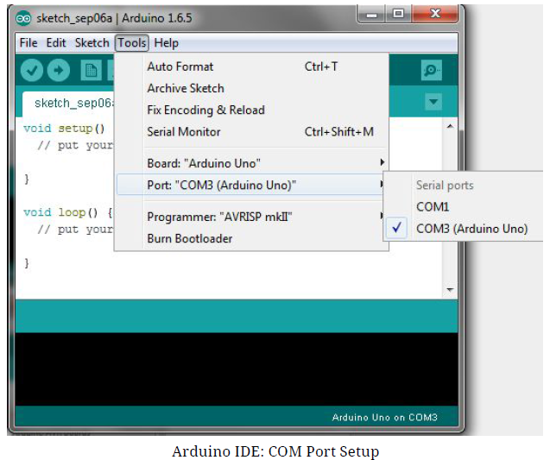

At this point, your board should be set up for programming, and you can begin writing and uploading code.

**Testing Your Settings: Uploading Blink**

One common procedure to test whether the board you are using is properly set up is to upload the “Blink” sketch. This sketch is included with all Arduino IDE releases and can be accessed by the **File** pull-down menu and going to **Examples, 01.Basics,** and then select **Blink** . Standard Arduino Boards include a surface-mounted LED labeled “L” or “LED” next to the “RX” and “TX” LEDs, that is connected to digital pin 13. This sketch will blink the LED at a regular interval, and is an easy way to confirm if your board is set up properly and you were successful in uploading code. Open the “Blink” sketch and press the “Upload” button in the upper-left corner to upload “Blink” to the board.

Upload Button: Arduino

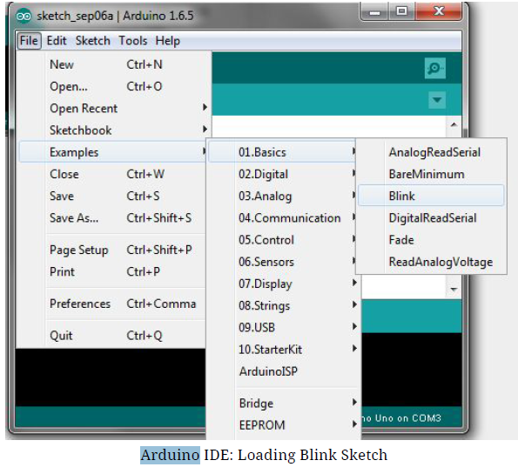

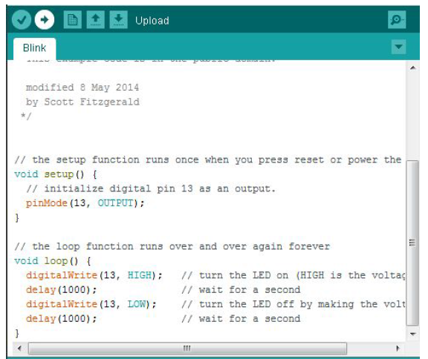

**Program:**

#include <Adafruit\_BMP085.h>

//#include <Wire.h>

#include "Wire.h"

#include "I2Cdev.h"

#include "MPU6050.h"

#include <LiquidCrystal.h>

#include <SoftwareSerial.h>

#include <TinyGPS.h>

LiquidCrystal lcd(13, 12, A3, A2, A1, A0);//RS,EN,D4,D5,D6,D7

MPU6050 mpu;

int16\_t ax, ay, az;

int16\_t gx, gy, gz;

struct MyData {

byte X;

byte Y;

};

MyData data;

int relay = 11;

//int pin = 7;

int state = 0;

const int pin = 7;

float gpslat, gpslon;

TinyGPS gps;

SoftwareSerial sgps(4, 5);

SoftwareSerial sgsm(2, 3);

void mpu\_data();

void main\_display();

void test\_sms();

void send\_sms();

void setup()

{

Serial.begin(9600);

sgsm.begin(9600);

sgps.begin(9600);

lcd.begin(16, 2);

Wire.begin();

mpu.initialize();

pinMode(relay, OUTPUT);

pinMode(pin,OUTPUT);

digitalWrite(relay,HIGH);

digitalWrite(pin,LOW);

//LCD DECLARATION

////////////////////////

lcd.clear();

lcd.setCursor(0,0);

lcd.print("\* Smart Helmet \*");

lcd.setCursor(0,1);

lcd.print("\*\*\*\*\*\*\*\*\*\*\*\*\*\*\*\*\*");

delay(3000);

lcd.clear();

lcd.setCursor(0,0);

lcd.print("<<< System >>>");

lcd.setCursor(0,1);

lcd.print("\*\*\* Using \*\*\*");

delay(3000);

lcd.clear();

lcd.setCursor(0,0);

lcd.print("<<< ARDUINO >>>");

lcd.setCursor(0,1);

lcd.print("\*\*\*\*\*\*\*\*\*\*\*\*\*\*\*\*\*\*\*");

delay(3000);

lcd.clear();

lcd.setCursor(0,0);

lcd.print("Sensor Scanning...");

lcd.setCursor(0,1);

lcd.print("....................");

delay(3000);

lcd.clear();

lcd.setCursor(0,0);

lcd.print(" GSM Modem ");

lcd.setCursor(0,1);

lcd.print("Initializing.......");

delay(8000);

test\_sms();

delay(8000);

lcd.clear();

}

void loop()

{

while (sgps.available())

{

int c = sgps.read();

if (gps.encode(c))

{

gps.f\_get\_position(&gpslat, &gpslon);

}

}

mpu\_data();

/////////////////////////////////

}

//////////////////////

void mpu\_data()

{

mpu.getMotion6(&ax, &ay, &az, &gx, &gy, &gz);

data.X = map(ax, -17000, 17000, 0, 255 ); // X axis data

data.Y = map(ay, -17000, 17000, 0, 255); // Y axis data

//delay(500);

Serial.print("Axis X = ");

Serial.print(data.X);

Serial.print(" ");

Serial.print("Axis Y = ");

Serial.println(data.Y);

if (data.Y < 80) { //gesture : down

Serial.print("gesture 1");

digitalWrite(pin, LOW);

}

if (data.Y > 145) {//gesture : up

digitalWrite(pin, HIGH);

if (digitalRead(pin) == HIGH )

{

sgsm.listen();

sgsm.print("\r");

delay(1000);

sgsm.print("AT+CMGF=1\r");

delay(1000);

/\*Replace XXXXXXXXXX to 10 digit mobile number &

ZZ to 2 digit country code\*/

sgsm.print("AT+CMGS=\"+918489056662\"\r");

delay(1000);

//The text of the message to be sent.

sgsm.print("Latitude :");

Serial.println(gpslat, 6);

sgsm.println(gpslat, 6);

sgsm.print("Longitude:");

Serial.println(gpslon, 6);

sgsm.println(gpslon, 6);

sgsm.print("Xaxis:");

sgsm.println(data.X);

//sgsm.print("Yaxis:");

//sgsm.println(data.Y);

delay(1000);

sgsm.write(0x1A);

delay(1000);

//state = 1;

main\_display();

}

send\_sms();

Serial.print("gesture 2");

}

if (data.X > 155) {//gesture : left

Serial.print("gesture 3");

}

if (data.X < 80) {//gesture : right

Serial.print("gesture 4");

}

if (data.X > 100 && data.X < 170 && data.Y > 80 && data.Y < 130) { //gesture : little bit down

Serial.print("gesture 5");

}

}

void main\_display()

{

lcd.setCursor(0,0);

lcd.print("Xax:");

lcd.print(data.X);

lcd.setCursor(8,0);

lcd.print("Yax:");

lcd.print(data.Y);

///////////gps data///////////

lcd.setCursor(0,1);

lcd.print("L:");

lcd.print(gpslat, 6);

lcd.setCursor(8,1);

lcd.print("G:");

lcd.print(gpslon, 6);

delay(500);

}

void test\_sms()

{

sgsm.println("AT+CMGF=1"); //To send SMS in Text Mode

delay(2000);

sgsm.println("AT+CMGS=\"8489056662\"\r"); // change to the phone number you using

delay(2000);

sgsm.println(" \*\* Smart Helmet with Tracking system \*\* : Device Connected ");//the content of the message

delay(1000);

sgsm.println((char)26);//the stopping character

delay(2000);

}

void send\_sms()

{

sgsm.println("AT+CMGF=1"); //To send SMS in Text Mode

delay(2000);

sgsm.println("AT+CMGS=\"8489056662\"\r"); // change to the phone number you using

delay(2000);

sgsm.println(" \*\* Smart Helmet please wear helmet then drive \*\* : Device Connected ");//the content of the message

delay(1000);

sgsm.println((char)26);//the stopping character

delay(2000);

}

**ADVANTAGES**

**ADVANTAGES**

* Less bulky & also easily transferable. It requires less power. So the system becomes chip,
* User Friendly & Cost Effective.
* It operates on less power & requires less space

**APPLICATION**

**APPLICATIONS**

* This smart helmet has three main features and each feature has its own purpose like the purpose of first feature is to encourage or force rider to wear helmet, similarly the purpose of second feature is to prevent rider to drink and drive, and third feature is to save lives as many as possible when accidents occur.
* It integrates alcohol sensing, helmet detection, crash detection, and instant communication capabilities to establish a comprehensive safety system. By disabling the bike when the rider is under the influence or not wearing a helmet, it promotes responsible riding practices. In case of an accident, the system promptly alerts authorities and designated individuals, facilitating rapid assistance and potentially saving lives.

**PHOTOGRAPHIC VIEW**

**PHOTOGRAPHY**

**CONCLUSION**

In conclusion, the intelligent helmet represents a noteworthy advancement in guaranteeing rider safety. Modern techniques for detecting alcohol, identifying accidents, tracking whereabouts, and detecting falls are all seamlessly combined, it enhances the protective capabilities of a traditional helmet. The standout feature lies in its capacity to identify alcohol levels, effectively preventing riders from operating their bikes under the influence. If the rider is found to be intoxicated, the intelligent helmet automatically immobilizes the bike’s ignition system.

Moreover, the helmet’s ability to send notifications containing the rider’s precise location to designated contacts adds an additional layer of security. In the unfortunate event of an accident, the intelligent helmet promptly utilizes the GSM and GPS modules to transmit distress messages, promptly notifying emergency services of the rider’s location and ensuring timely assistance. By incorporating advanced features and comprehensive safety measures, the intelligent helmet aims to significantly enhance rider safety on the road, making the biking experience considerably safer and more secure. Its focus on prioritizing rider well-being, mitigating risks, and enabling prompt assistance underscores its vital role in ensuring a secure and enjoyable riding experience.

**COST ESTIMATION**

Cost Estimation

|  |  |  |
| --- | --- | --- |
| **SOLDIER’S HEALTH MONITORING AND POSITION TRACKING SYSTEM**  COST ESTIMATION | | |
| **COMPONENTS** | **QUANTITY** | **COST** |
| **ARDUINO** | 01QQ | Rs.630 |
| **ACCELEROMETER SENSOR** | 01 | Rs.200 |
| **MOTOR & DRIVER** | 01 | Rs.1800 |
| **MAX232 INTERFACE** | 01 | Rs.1300 |
| **DECODER** | 01 | Rs. 250 |
| **DISPLAY** | 01 | Rs. 175 |
| **POWER SUPPLY** | 01 | Rs.100 |
| **OTHER COMPONENTS** | As Per Requirement | Rs. 395 |
| **GPS MODULE** | 01 | Rs. 600 |
| **GSM MODULE** | 01 | Rs. 900 |
| **PCB BOARD CHARGES** | As Per Requirement | Rs. 800 |
| TOTAL |  | Rs.7050 |

**ENTERPRENEURSHIP**

**INTRODUCTION:**

Entrepreneurship is the practice of starting new organizations and establishing revitalizing matured organization..It is defined as the organizer or promoter of an activity, especially one who assumes the risks of a business.

The successful entrepreneur promoter the vision. The person is usually a positive thinker and a decision maker. Taking decision in various stages like converging on the idea, business plan, business formation, growth, going to public or marketing.

The industries can be listed into three major types namely, Small scale industries (SSI), Medium scale industries (MSI), Large scale industries (LSI).

**SELECTING THE MOST SUITABLE LOCATION FOR THE INDUSTRY**

An important relates to the suitable location of an industry. The primary factors that govern the location of a plant are

* Raw Material
* Market
* Transport
* Power
* Labor

Since most of the industries in the field of Electrical & Electronics Fall under the “Assemble Line”, the sight need not be near to the place where the raw material (Mostly the ICs, Transistor, Resistor, Sockets) are readily the components bulk do not cost the manufacturers must. The finished product must reach to the markets. The facilities for transport of finished goods available in a particular region and the policy of freight rates must also be considered. Industry can be started only at places where the right type of labor is abundantly at the reasonable wages.

Each state government and central government has been trying to promote industrial development in relatively backward regions by offering various concessionsand incentives in the form of financial assistance. Some land, tax subsidy, and power tariff concession etc., to new enterprises. Some of the facilities concessions available from the Tamil Nadu State Government through TNIDC – Madras, TNIIC – Madras, SIPCTIN & Madras as follow

* Interest free sales tax loan given to the extent of sales tax paid by the units for 3 years to a maximum of 25% of the fixed assets of the expansion or diversification scheme.
* Financial assistance by way of loan up to 2 lakhs is for purchase of land, machinery, and equipment. Construction of factory etc, and also working capital granted on merits.
* Equity participation offered by the government through TIIC and the SIPCIN

Secondary factor which govern through not of very much important but must be considered while selecting a site are;

* Climate
* Personal Stability
* Political Stability
* Special Concession and benefits Industrial atmosphere
* Priority of a location

The lack political stability in a state make for uncertainty in the Attitude of State government to industry. In locating a plant, it must be seen as to whether the state has a record of political and economical stability.

The site should be connected in road and rail. The existence of facilities for disposal of water or effluent water is important. Most of the electronic industry does not need this. Also the available land should be sufficient for purpose of the unit and also posses the requirement of future expansion.

The guiding principle in the fixation of optimum location for the plant is that it must result in the lowest unit cost of producing and distributing the product to the consumers. Such economic factors like.

(1) Cost of plant size

(2) Labour cost

(3)Cost of fuel, power, water

(4) Freight charged on finished products

(5) Freight charged on raw materials.

**LOANS AND ADVANCES FROM BANKS AND FINANCIAL INSTITUTION**

To help the entrepreneurs in the beginning stage, the state as well as the central government as established some financing institution to lend money on less interest, apart from the commercial banks. Some of the aspects of them are dealt with here.

**TAMIL NADU INVERSMENT CORPORATION**

TIIC helps for development of backwards areas, assistance to the priority sectors etc., it has to assist the technocrats, educated unemployed and to promote sales and develop the backwards areas.

LOANS MINIMUM Rs.5000/-

LOANS MAXIMUM Rs.60,00,000/-

For corporate bodies the maximum is Rs.60,00,000/-

For partnership and proprietary concerns the maximum is Rs.95,00,000/-

**DISTRICT INDUSTRIAL CENTRE (DIC) AND COMMERCIAL BANKS:**

The DIC centers provide all the services and facilities to the entrepreneurs at tone place for seating up small and village industries. A General Manager who is assisted by seven Functional Managers heads a DIC, each is a specialist in the following subjects:

(1) Economical investigation

(2) Machinery and Equipment

(3) Research, extension and training

(4) Raw Materials

(5) Credit

(6) Marketing and

(7) Cottage Industries.

**COMMERCIAL BANKS:** The commercial banks are established a corporate body with shares holding by private individuals, but subsequently there has been a drift state ownership and control By issue of public shares, namely equity, preference shares, or debentures or from public deposits.

**INDUSTRIAL FINANCE CORPORATION: (IFC)**

IFC is to render financial assistance to large scale industrial concerns, particularly when the ordinary bank accommodation does not suit the concern, or finance cannot be repayable in period of (Max) 15 Years.

**INDUSTRIAL CREDIT AND INVESTMENT CORPORATION (ICIC):**

Industrial credit and Investment Corporation aims at

* Assisting in the creating, expansion and modernization industrial with in the private sector.
* Encouraging the inflow and participation of foreign capital in the unit.
* The expansion of investment market in the India.

**NATIONAL SMALL INDUSTRIES CORPORATION LIMITED (NSIC)**

Its objectives are to aid, counsel, assists, and finance (indirect), protect and promote the interests of the small industries in the country. It offers a wide range of service to small industries units, such as indigenous machinery and equipment of easy installment under the hire purchase scheme, straining of skilled workers through its four-prototype development and training centers and marketing (Okla., Rajkot & Madras). It also helps in obtaining raw material and in exporting the products of small industries.

**INDUSTRIAL RECONSTRUCTION CORPORATION OF INDIA LIMITED:**

Assistance in the form of soft loans and guarantees and help in reconstructing of the mismanagement which has led to the short coming of the unit by surrounding technical and managerial guidance and as catalyst in securing assistance from banks and financial institution and government agencies.

**DOCUMENTS FOR GETTING LOANS**

**SMALL SCALE INDUSTRIES**

These are the industries such that the investment on machinery and equipment’s should be more than 25 lakhs, but does not exceed 5 crores.

**MEDIUM SCALE INDUSTRIES:**

These are the industries such that the investment on machinery and equipment should be more than 5 crores and does not exceed 20 crores.

**LARGE SCALE INDUSTRIES:** These are the industries such that the investment on machinery and equipment should between 5 crores and 100 crores.

**POWER SUPPLY:**

The subside on power tariff is brought to the industries, which are started after 01.01.1980 as follows:

For First Year \_\_\_\_\_\_\_\_\_\_\_\_\_\_\_\_30% power subsidy

Second Year \_\_\_\_\_\_\_\_\_\_\_\_\_\_\_\_\_20% Power subsidy

Third Year \_\_\_\_\_\_\_\_\_\_\_\_\_\_\_\_10% Power Subsidy.

**SUBSIDY FOR SELECTION SATEGORY OF INDUSTRIES:**

The State Government with a view to develop the Industries coming under the following categories has announced 10% subsidy for selected categories.

* Electrical Industries
* Drug and formulation of scheduled drugs
* Ancillary work shop (Automobile)
* Manufacture of equipment and machinery to tap solar energy for domestic and other Industrial purpose.

**1.WHAT ARE THE QUALITIES OF AN ENTERPREUNER ?**

**ANS:** The Qualities Of An Enterprenur Are :

* High level confidence
* Vision And Passion In Their Dreams
* Surround Themselves With Other Like Minded People
* Highly Resourceful, Creative And Inventive
* Size Oppurtunities And Create Their Own Whenever Possible
* Know What Motivates Them
* Spend A Substantial Amount Of Time On Introspection
* Refuse To Let Other People Dictate How They Should Live
* Take Responsibility For Their Happiness

**2.IDENTIFY THE INFRACTRUCTUAL NEEDS FOR AN INDUSTRY**

**ANS:** The Infrastructure Needs For An Industry Are(6’m’s)

Man Machine Material

Money Market Management And

Land Water Transport Electricity

**3.WHAT IS AN INDUSTRIAL ZONE?**

**ANS:** Industrial Zone Was Intially Introduced As A Term To Describe An Area Where Workers Of A Monolithic Heavy Industry (Ship-Building,Coal Mining, Steel, Ceramics,Etc) Live Within Walkingdistance Of Their Places Of Work.

**4.WHAT IS AN INDUSTRIAL ESTATE ?**

**ANS:**  An Industrial Park Is An Area Zoned And Planned For The Purpose Of Industrial Development Parks Are Usually Known As Industrail Estates.

**5.WHAT ARE THE ADVANTAGES OF BECOMING AN ENTERPRENEUR ?**

**ANS:**

* Enterpreneurs enjoy the freedom of making their own business decisions and becoming thier own bosses.
* IIn addition, they also gain the stability and control that could never be achieved as regular employee.
* Compared to being regular employees, enterpreneurs enjoy much excitement beginning from the planning stage of the business up to development and realization.
* Thrill-seekers obviously love being entrepreneurs as they are exposed to too much risk.

**6.WHAT ARE THE TYPES OF ENTERPRENEURS?**

**ANS:**

* The idealist entrepreneur is the most common type of entrepreneur likes innovation and enjoys or something personally Meaningful.
* The optimizer entrepreneur is content with the personal satisfaction of simply being a business owner.
* The hard worker entrepreneurs category includes persons who enjoy putting in long hours to build a larger more profitable business.
* The juggler entrepreneurs handles everything themselves . They are usually people with lots of energy.
* The sustainer’s entrepreneur category consists of people who like the thought of balancing work and a personal life most often they do not wish the business to grow too large where it will cut into their personal life too much.